Project Tortoise – Assistive Technology for Memory Loss

Team Members: Efaz Hossain, Sahithi Mutyala
Report Submission Date: February 9, 2025

- Introduction
- Summary
- Progress and Milestones
- Problem-Solving and Challenges
- Technical Depth and Accuracy
- Future Plans and Goals

Introduction
Over the past four weeks and including the winter break from last semester, Project Tortoise has made significant progress in developing a facial recognition and object recognition system to support individuals with memory loss. The primary focus during this period was to establish a robust automatic object detection model, building on prior work in facial recognition. To achieve this, we performed exploratory data analysis (EDA), dataset preprocessing and automated bounding box labeling using YOLO11. The 2.2 GB dataset needed efficient management and optimization for faster processing. This report will detail the progress made, challenges faced, technical developments and future goals for the next phase of the project.

Summary
During this period, we completed dataset structuring, exploring data analysis and implemented automated object labeling. Specifically, we conducted exploratory data analysis to analyze image distributions and class counts, preprocessed images by ensuring uniform resolution and normalization, and split the dataset into training, validation and test sets (70-15-15). Additionally, we implemented automatic box labeling using a pre-trained YOLO model. A major challenge faced during this phase was the large dataset size, which caused slow processing speeds.
Graphs and Visualizations
The visualizations below provide a comprehensive understanding of the dataset and its structure. The first figure illustrates sample images from the dataset, showcasing three object categories: cellphone, wallet and watch. Each row represents a specific class, and the images reflect diverse angles, lighting conditions and object orientations. This variety ensures robust learning during the training phase by exposing the model to different real-world scenarios. 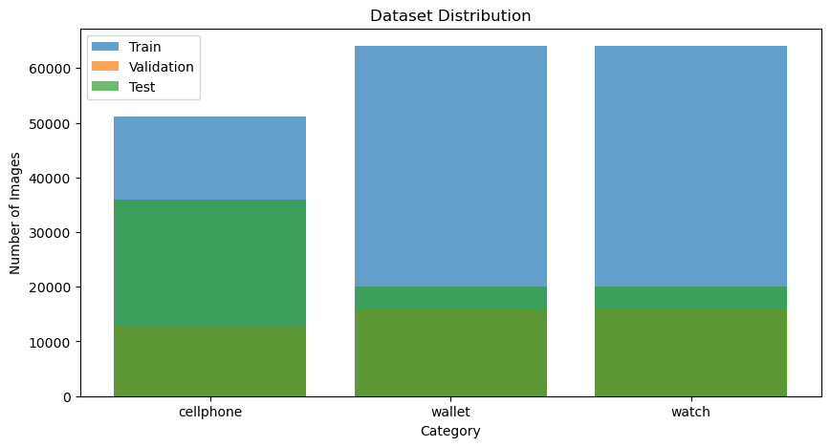
The second figure represents the dataset distribution across the three categories: cellphone, wallet and watch. The bar chart divides each category into its respective train, validation and test splits, adhering to a ratio of 70% for training, 15% for validation and 15% for testing. While the dataset size varies slightly between categories, it’s evident that wallet and watch categories have a larger sample size compared to cellphones. This distribution highlights the need for potential dataset balancing, particularly for categories with fewer images, to prevent model bias towards more over-represented classes. 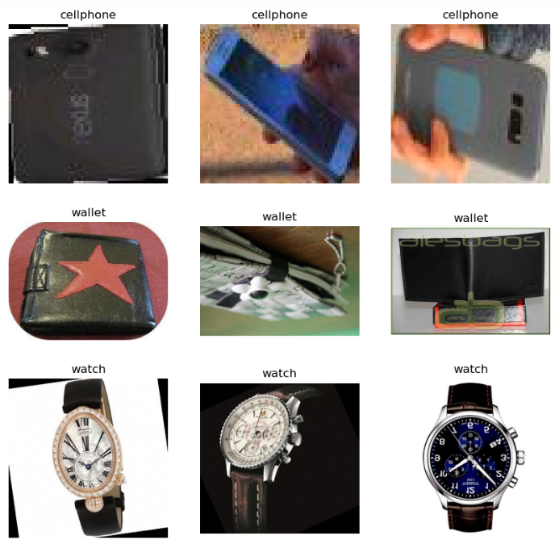
These visualizations underscore the diversity and structure of the dataset, aiding in better understanding and preparation for the model training process.

Progress and Milestones
Completed Tasks
The dataset was successfully structured and cleaned for object detection. An exploratory data analysis (EDA) was conducted to assess class balance and dataset composition. Automatic bounding box generation was established to streamline annotation. The accuracy of labeled bounding boxes was verified using visualization techniques.
Pending Tasks
Further work is required to optimize dataset size by reducing the number of images per class to improve processing speed. The training of a base YOLO11 model for object detection has yet to begin, but we plan to make a back-bone model utilizing YOLOv9 to start training. Further refinements in automated labeling efficiency are necessary to speed up processing as we plan to make this a ‘live’ model that will continuously feed new data and create a database to store recognized objects and faces.

Problem-Solving and Challenges
Challenges Encountered
One of the major challenges faced during this period was the large dataset size which significantly slowed down automatic labeling and model training. Additionally, manual annotation was impractical given the dataset scale, requiring a more efficient automated approach.
Approaches and Solutions
To address the dataset size issue, we are planning to reduce the number of images per class while ensuring that the dataset remains balanced. For automated labeling, we implemented a pre-trained YOLOv9 model to generate bounding boxes for objects instead of manually labeling each image. It would be rather tasking to go through approximately 180,000 images from the train set and 15% of that for test and validation all manually. However, processing remains slow, and we are exploring optimization techniques such as adjusting YOLO settings and increasing computational efficiency. We also are utilizing the GPU server provided for the team during the Capstone course to process all this much easier.
Impact of Solutions
By using YOLO-based automated labeling, we have significantly reduced the manual effort required for annotation. The dataset reduction strategy will further enhance processing speed and training efficiency, allowing us to train the object detection model in a more optimized manner.

Technical Depth and Accuracy
Future Plans and Goals

